**CSE 343 Software Engineering**

**HW #2**

**Berkan AKIN**

**171044073**

**a)**

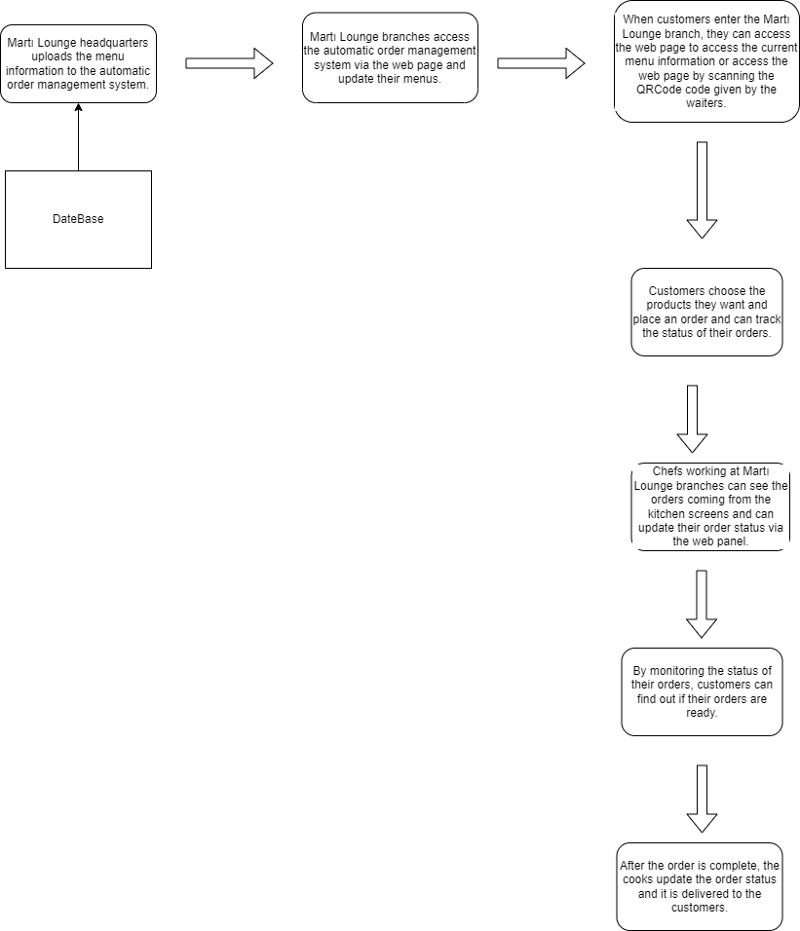

**b)**

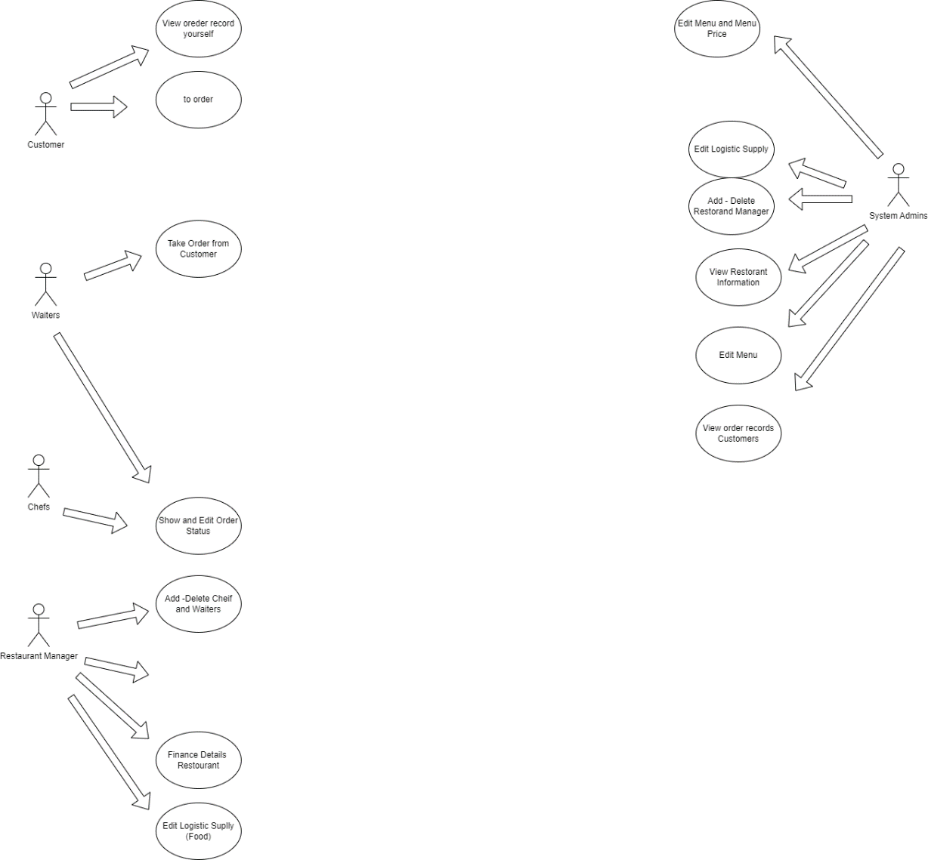

|  |  |
| --- | --- |
| System | Martı Lounge Restaurant management system |
| Use Case | View oreder record yourself |
| Actors | Customer, |
| Data | Customer recent order |
| Stimulus | Applıcation main menu |
| Response | Show recent order |
| Commnets |  |

|  |  |
| --- | --- |
| System | Martı Lounge Restaurant management system |
| Use Case | To Order |
| Actors | Customer |
| Data | food menus, order details |
| Stimulus | Show Menu |
| Response | Record database and noticifitaion waiters and chefs |
| Commnets |  |

|  |  |
| --- | --- |
| System | Martı Lounge Restaurant management system |
| Use Case | Take Order from Customer |
| Actors | Waiters |
| Data | Food menus, order details |
| Stimulus | Show Menu and Customer give order |
| Response | Record database and noticifitaion waiters and chefs |
| Commnets |  |

|  |  |
| --- | --- |
| System | Martı Lounge Restaurant management system |
| Use Case | Show and Edit Order Status |
| Actors | Chefs, Waiters |
| Data | Food menus, order details |
| Stimulus | Customer to order in menu |
| Response | Editing Menu |
| Commnets |  |

|  |  |
| --- | --- |
| System | Martı Lounge Restaurant management system |
| Use Case | Add -Delete Cheif and Waiters |
| Actors | Restoran Maneger |
| Data | Cheif and Waiter Information |
| Stimulus | Admin page |
| Response | Editing Cheif and Waiters information |
| Commnets |  |

|  |  |
| --- | --- |
| System | Martı Lounge Restaurant management system |
| Use Case | Add -Delete Cheif and Waiters |
| Actors | Restoran Maneger |
| Data | Cheif and Waiter Information |
| Stimulus | Admin page |
| Response | Editing Cheif and Waiters information |
| Commnets |  |

|  |  |
| --- | --- |
| System | Martı Lounge Restaurant management system |
| Use Case | Edit Finance Details  Restourant |
| Actors | Restourant Maneger |
| Data | Restourant Financial Information |
| Stimulus | Admin page |
| Response | Chancing Financial Information |
| Commnets |  |

|  |  |
| --- | --- |
| System | Martı Lounge Restaurant management system |
| Use Case | Edit Logistic Suplly (Food) |
| Actors | Restourant Maneger |
| Data | Restourant Financial Information |
| Stimulus | Admin page |
| Response | Chancing Logistic Suplly |
| Commnets |  |

|  |  |
| --- | --- |
| System | Martı Lounge Restaurant management system |
| Use Case | Edit Menu and Menu Price |
| Actors | System Admin |
| Data | Menu Detail |
| Stimulus | Admin page |
| Response | Chancing Menu and Menu Price |
| Commnets |  |

|  |  |
| --- | --- |
| System | Martı Lounge Restaurant management system |
| Use Case | Edit Logistic Suplly (Food) |
| Actors | System Admin |
| Data | Logistic Sublly Data |
| Stimulus | Admin page |
| Response | Chancing Logistic Information |
| Commnets |  |

|  |  |
| --- | --- |
| System | Martı Lounge Restaurant management system |
| Use Case | Add - Delete Restorand Manager |
| Actors | System Admin |
| Data | Restoran maneger Information |
| Stimulus | Admin page |
| Response | Add or delete person |
| Commnets |  |

|  |  |
| --- | --- |
| System | Martı Lounge Restaurant management system |
| Use Case | View order records Customers |
| Actors | System Admin |
| Data | Customer Information and Order record |
| Stimulus | Admin page |
| Response | Show Status order |
| Commnets |  |

|  |  |
| --- | --- |
| System | Martı Lounge Restaurant management system |
| Use Case | View Restorant Information |
| Actors | System Admin |
| Data | Financial and logistic informaton |
| Stimulus | Admin page |
| Response | Show Financial and logistic details information |
| Commnets |  |

|  |  |
| --- | --- |
| System | Martı Lounge Restaurant management system |
| Use Case | Edit Menu |
| Actors | System Admin |
| Data | Financial and Logistic informaton |
| Stimulus | Admin page |
| Response | Show Financial and logistic details information |
| Commnets |  |

**c)**

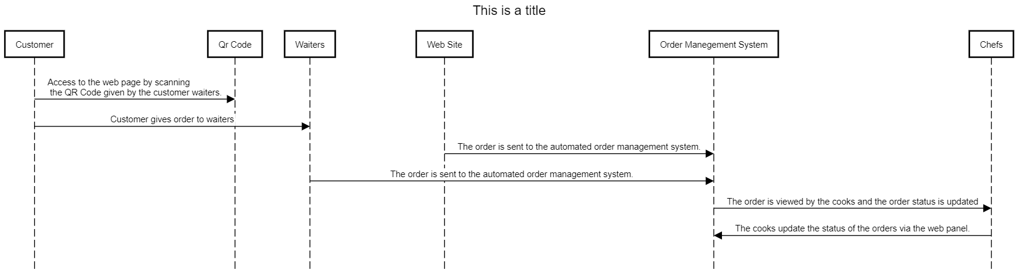

**d)**

